USED CAR PRICE ANALYSIS

BY
Abhinav Davu

Contents:
Section | Title | Page
 | Contents | 2
1. | Abstract | 3
2. | Introduction | 4
3. | Problem Statement | 5
3.1 | Core Objectives | 6
4. | Methodology | 6
4.1 | Data Collection (Web Scraping) | 7
4.1.1 | Web Scraper Implementation | 8
4.2 | Data Cleaning and Processing | 15
4.3 | Data Transformation and Manipulation | 16
4.4 | Data Analysis | 27
4.5 | Visualization and Reporting | 27
4.6 | Conclusion (Methodology Section) | 31
5. | System Design & Architecture | 31
5.1 | Architecture Overview | 32
5.2 | Explanation of Each Component | 33
6. | Tools & Technologies | 34
7. | Conclusion | 35

ABSTRACT:

This project analyzes a multi-city dataset of used cars listed on the Droom platform to understand how key attributes such as brand, year, kilometres driven, fuel type, transmission, and location influence resale prices in the Indian market. The raw listing data was cleaned and standardized using Python and Excel, then modelled and visualized in Power BI to derive pricing patterns by brand, city, and vehicle characteristics. The final output is a clean analysis-ready Excel file and an interactive Power BI dashboard that can support data-driven decisions for buyers, sellers, and platform operators.

2. Introduction:

The Indian used-car market is expanding rapidly, with online platforms such as Droom aggregating thousands of listings from multiple cities and brands. While this creates choice for consumers, it also introduces significant price variability driven by vehicle age, usage, fuel type, and city-specific demand. Accurately estimating a fair resale price is therefore non-trivial.​
This project, “Used Car Price Analysis”, focuses on transforming a scraped / exported Droom listing file into clean, structured data and using Power BI to explore how price varies across brands, fuel types, transmissions, cities, and model years.
Once the dataset is reliably structured, it is imported into Power BI, where relationships between variables are explored through interactive dashboards and visual analytics. Bar charts, scatter plots, and donut charts reveal how average prices differ across brands and cities, how usage patterns vary by fuel type and transmission, and how factors like age and kilometres driven jointly influence resale value. These visuals allow stakeholders to drill down by location, brand, or model year, converting raw marketplace data into actionable intelligence for pricing strategy and purchase decisions

3. Problem Statement:
Prices of pre-owned vehicles listed on Droom are not standardized and depend on multiple interacting factors such as brand, year of manufacture, kilometres driven, fuel type, transmission, and listing location. Noise in the raw data (inconsistent formats for KMs and price, missing values, outliers, and obvious data-entry mistakes) further complicates analysis.​
The project aims to build a cleaned dataset and an interactive dashboard that answer questions like:
- Which brands and cities have higher average used-car prices?​
- How do price and KMs driven relate for different fuel types and transmissions?​
- Are there obvious outliers or unrealistic prices that need correction before analysis?​

3. 1 Core Objectives:
The primary goals of this technical endeavor were to:
- Acquire Data: Develop a Python-based tool to scrape and aggregate used car listings from the online platform Droom.in
- Standardize Data: Clean, normalize, and transform raw text fields (Price, KMs Driven, Car Name) into structured numeric and categorical features.
- Derive Insights: Analyze the cleaned dataset to identify and visualize the primary factors contributing to price variations across different brands and cities.
- Final Output: Produce a clean, analysis ready .xlsx file containing the standardized used car market data.
- Drawing insights to help users make informed purchase or selling decisions.
4. Methodology
The project follows a data analytics life cycle, beginning from data collection through web scraping to visualization and insight generation.
Each stage has been implemented using Python, Jupyter Notebook, and Power BI for end-to-end analysis.

The workflow of the project consists of the following key phases:
- Data Collection (Web Scraping)
- Data Cleaning and Processing
- Data Transformation and Manipulation
- Data Analysis
- Visualization and Reporting
- Conclusion and Insights

4.1 Data Collection
- Source Website: https://droom.in/
- Objective: The initial phase focused on acquiring raw, unstructured data from the online automobile platform, https://droom.in/
- Gather comprehensive, structured listings for used cars, including key attributes like City, Car Name, Year, Price, KMs Driven, Fuel Type, and Transmission.

4.1.1 Web Scraper Implementation:
The data was collected using Python's core libraries dedicated to fetching and parsing web content

Component | Library Used | Function
HTTP Requests | requests | Used to send requests to the Droom server to fetch HTML content for various listing pages.
HTML Parsing | BeautifulSoup | Employed to navigate and extract targeted data points (City, Car Name, Price, KMs Driven, Fuel Type, Transmission) from the structured HTML
Data Aggregation | pandas | Used to organize the extracted, raw data records into a sequential DataFrame structure.

Code Snippet: Web Scraping (Python)

# Install necessary libraries
# !pip install requests beautifulsoup4 pandas openpyxl
# Import necessary libraries
import requests
from bs4 import BeautifulSoup
import pandas as pd
# Updated CITIES dictionary with few specific cities PLUS the general all_india page
CITIES = {
# General Page Added
"all_india": "https://droom.in/cars/used",
# Existing Cities
"hyderabad": "https://droom.in/cars/used/hyderabad",
"delhi": "https://droom.in/cars/used/delhi",
# Other Cities
"mumbai": "https://droom.in/cars/used/mumbai",
"pune": "https://droom.in/cars/used/pune",
"bangalore": "https://droom.in/cars/used/bangalore",
"chennai": "https://droom.in/cars/used/chennai",
"gurgaon": "https://droom.in/cars/used/gurgaon",
"jaipur": "https://droom.in/cars/used/jaipur",
"kolkata": "https://droom.in/cars/used/kolkata",
}
HEADERS = {
'User-Agent': 'Mozilla/5.0 (Windows NT 10.0; Win64; x64) AppleWebKit/537.36 (KHTML, like Gecko) Chrome/91.0.4472.124 Safari/537.36',
'Accept-Language': 'en-US,en;q=0.9',
'Accept': 'text/html,application/xhtml+xml,application/xml;q=0.9,image/webp,*/*;q=0.8'
}

# 2. Function to scrape data
def scrape_droom_cars(url, city_name, headers):
"""Fetches and parses a single Droom search page."""

# Error handling and initial fetch
try:
response = requests.get(url, headers=headers)
response.raise_for_status()
except requests.exceptions.RequestException as e:
print(f"Error fetching {city_name.upper()} page: {e}")
return []

soup = BeautifulSoup(response.content, 'html.parser')
cars_data = []

# Find all Car Name elements
car_name_elements = soup.find_all('h5', class_='w-[89%] text-base font-medium')

for name_element in car_name_elements:
car = {}

# Car Name
car['Name'] = name_element.text.strip()

# CRITICAL FIX: Find Parent Container for Scoping
# Traverse up 3 levels to find a common, large container for the listing
listing_container = name_element.find_parent('div').find_parent('div').find_parent('div')

if not listing_container:
continue

# --- Price ---
price_element = listing_container.find('h6', class_='font-semibold text-[#30343e]')
car['Price'] = price_element.text.strip().replace('₹', '').replace(',', '') if price_element else 'N/A'

# --- Other Details (KMs, Location, Fuel, Gear) ---
detail_spans = listing_container.find_all('span', class_='ps-2 text-xs font-thin capitalize text-[#30343e]')

details = [span.text.strip() for span in detail_spans]

# Assign values based on the expected order
car['KMs'] = details[0] if len(details) > 0 else 'N/A'
# Set the Location field to the current city name (from URL) for clarity
car['Location'] = city_name.replace('_', ' ').title() # Title case for readability
car['Fuel Type'] = details[2] if len(details) > 2 else 'N/A'
car['Transmission'] = details[3] if len(details) > 3 else 'N/A'

cars_data.append(car)

return cars_data

# 3. Execution and Saving
if __name__ == "__main__":

all_car_listings = []

# Loop through all configured cities
for city, url in CITIES.items():
print(f"\n--- SCRAPING: {city.replace('_', ' ').upper()} ---")

# Scrape data for the current city
car_listings = scrape_droom_cars(url, city, HEADERS)

if car_listings:
print(f"Successfully scraped **{len(car_listings)}** listings for {city}.")
all_car_listings.extend(car_listings)
else:
print(f"Failed to scrape any data for {city}. This often means the site is blocking access or the URL is invalid.")

# --- Save Combined Data ---
if all_car_listings:
print(f"Total combined listings scraped across all cities/pages: **{len(all_car_listings)}**")

df = pd.DataFrame(all_car_listings)
output_filename = 'droom cars1.xlsx'

try:
df.to_excel(output_filename, index=False, engine='openpyxl')
print(f"Data successfully saved to **{output_filename}** in XLSX format. ✅")
except Exception as e:
print(f"Error saving to Excel file: {e}")
else:
print("\nScraping finished, but no data was collected from any city. ❌")

4. 2. Data Cleaning and Processing:

The raw data required several steps to be transformed into a usable format, which was critical for ensuring the integrity of the subsequent analysis.

Standardizing KMs

Removed commas from the KMs field and converted it into a numeric column KMs_Numeric, enabling aggregation and scatter plotting.​

Type Conversion and Derived Columns

Set Year as integer, Brand, Fuel Type, Transmission, and Location as categorical fields, and kept both formatted price text and numeric Lakhs for visuals.​

Ensured there were no remaining missing values in essential columns by dropping or fixing incomplete rows.​

The cleaned dataset was saved as a final Excel file for loading into Power BI.

4. 3. Data Transformation and Manipulation:
- The cleaned data was structured with key columns including City, Brand, Car Name, Year, Price (Rs.), KMs (Numeric), Fuel Type, and Transmission, and saved to an .xlsx file for analysis.
Code Snippet for data cleaning and processing:

import pandas as pd

1.

# Read the Excel file

df = pd.read_excel("droom cars1.xlsx")

# Extract year from 'Name' column

df['Year'] = df['Name'].str.extract(r'(\b\d{4}\b)') # extract 4-digit year

# Remove the year from the 'Name' column text if you want

df['Name'] = df['Name'].str.replace(r'\b\d{4}\b', '', regex=True).str.strip()

# Save the updated DataFrame as .xlsx file

df.to_excel("droom_cars_final.xlsx", index=False)

print("✅ File saved successfully as 'droom_cars_final.xlsx'")

2.

df = pd.read_excel("droom_cars_final.xlsx")

df['Brand'] = df['Name'].str.split().str[0]

df.to_excel("droom_cars_final.xlsx", index=False)

print("✅ Brand column added and 'droom_cars_final.xlsx' updated")

3.

# Read your Excel file

df = pd.read_excel("droom_cars_final.xlsx")

# Clean 'Price' column — remove non-numeric characters and convert to numbers

df['Price'] = pd.to_numeric(

df['Price'].astype(str).str.replace(r'[^0-9.]', '', regex=True),

errors='coerce')

# Convert price to lakhs (2 decimal points)

df['Price_in_Lakhs'] = (df['Price'] / 100000).round(2).astype(str) + ' Lakhs'

#: Save updated file (same final file)

df.to_excel("droom_cars_final.xlsx", index=False)

print("✅ 'Price_in_Lakhs' column added successfully and saved in 'droom_cars_final.xlsx'")

4.

# Read your Excel file

df = pd.read_excel("droom_cars_final1.xlsx")

# Clean 'Price' column — remove non-numeric characters and convert to numeric

df['Price'] = pd.to_numeric(

df['Price'].astype(str).str.replace(r'[^0-9.]', '', regex=True),

errors='coerce')

# Convert price to lakhs with ₹ symbol and two decimal points

df['Price_in_Lakhs'] = '₹' + (df['Price'] / 100000).round(2).astype(str) + ' Lakhs'

# Save updated file

df.to_excel("droom_cars_final.xlsx", index=False)

print("✅ 'Price_in_Lakhs' column added with ₹ symbol and saved in 'droom_cars_final.xlsx'")

5.

# Read your Excel file

df = pd.read_excel("droom_cars_final1.xlsx")

# Clean 'Price' column — remove non-numeric characters and convert to numeric

df['Price'] = pd.to_numeric(

df['Price'].astype(str).str.replace(r'[^0-9.]', '', regex=True),

errors='coerce')

# Create formatted Price column (₹ and Lakhs)

df['Price_in_Lakhs'] = '₹' + (df['Price'] / 100000).round(2).map('{:.2f}'.format) + ' Lakhs'

# Drop old Price column

df.drop(columns=['Price'], inplace=True)

# Rename 'Price_in_Lakhs' → 'Price'

df.rename(columns={'Price_in_Lakhs': 'Price'}, inplace=True)

# Save the updated file

df.to_excel("droom_cars_final.xlsx", index=False)

print("✅ Old 'Price' removed, formatted 'Price' column added, and file saved in 'droom_cars_final.xlsx'")

6.

# Read your Excel file

df = pd.read_excel("droom_cars_final1.xlsx")

# Rearrange columns in desired order

new_order = ['Brand', 'Name', 'Location', 'Fuel Type', 'Transmission', 'Year', 'KMs', 'Price']

df = df[new_order]

# Save the updated file

df.to_excel("droom_cars_final.xlsx", index=False)

print("✅ Columns rearranged and file saved in 'droom_cars_final.xlsx'

4. 5. Visualization and Reporting:
- Tools Used: Power BI
- Data Input: Cleaned Excel File (droom_cars_final.xlsx)

- Analysis Performed:
  - Price VS Kms Driven
  - Avg Selling price by brand
  - Top 5 expensive cars
  - Avg selling price by location

Power BI was used to create interactive dashboards with filters, slicers, and visual comparisons that made the data insights more meaningful.

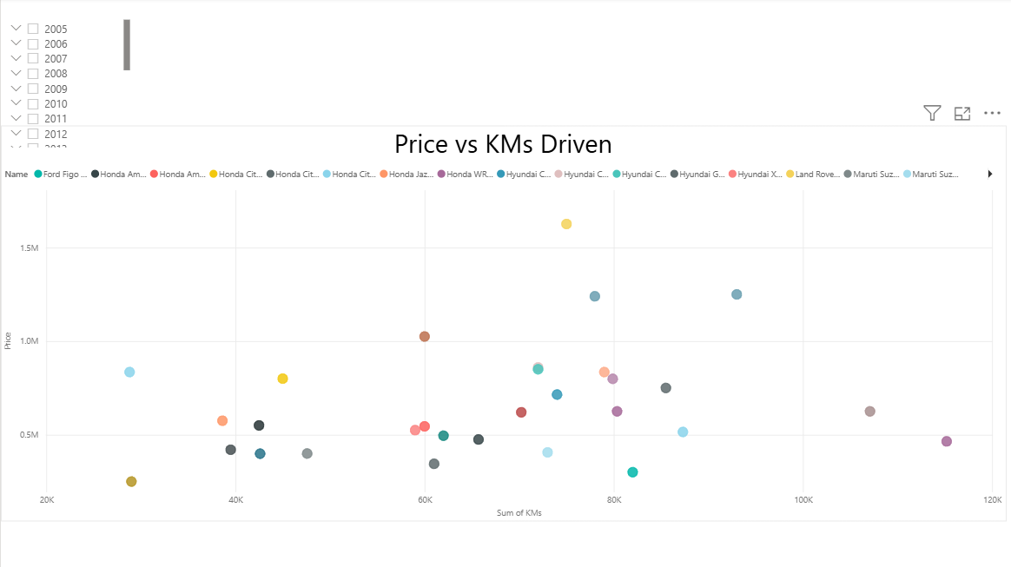

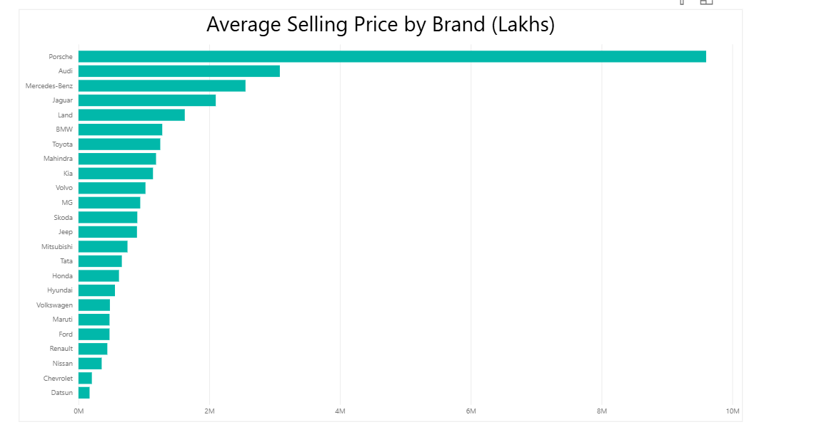

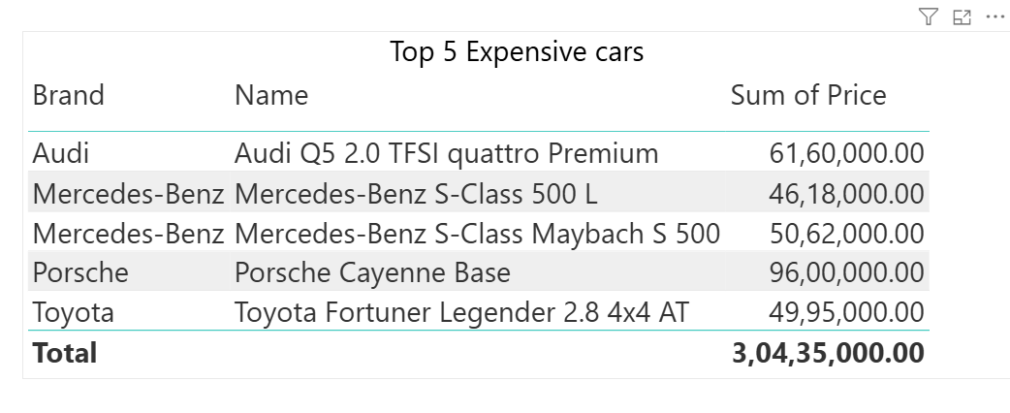

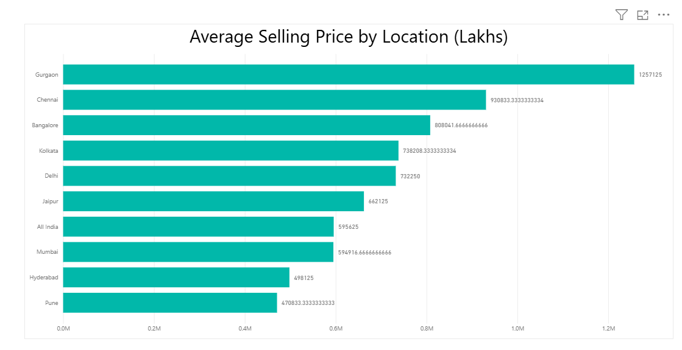

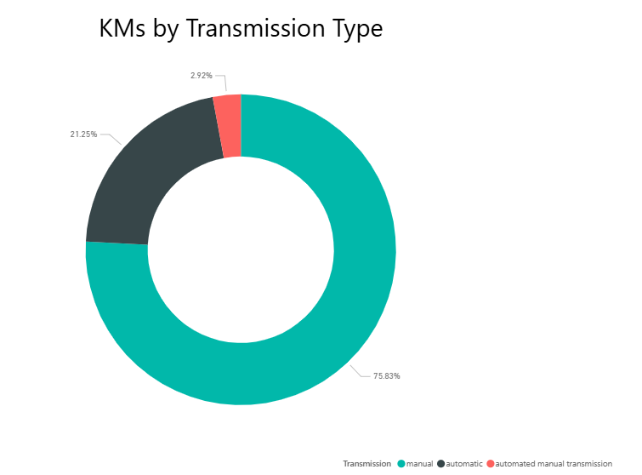

4. 6. Conclusion:

The project successfully converted noisy Droom used-car listings into a clean, analysis-ready dataset and produced a Power BI dashboard that exposes meaningful patterns in the Indian used-car market. By standardizing price and KMs, correcting outliers, and building intuitive visuals, the analysis supports more transparent and data-driven pricing decisions for stakeholders.​

Future extensions could include integrating additional data sources (e.g., other listing platforms), building predictive models for price estimation, and automating periodic refresh of the dashboard as new Droom data becomes available

System Design & Architecture:

The system architecture of the Used Car Price Analysis project is designed to handle data collection, cleaning, analysis, and visualization efficiently. The workflow ensures a seamless transition from raw web data to actionable insights.

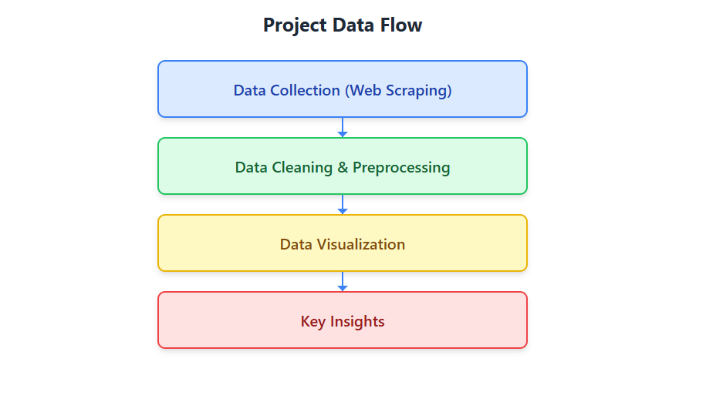

5.1 Architecture Overview
The architecture consists of the following layers:

Data Collection
  - Scrapes car listings from Droom.in
  - Handles multiple city URLs dynamically.

Data Cleaning
  - Cleans and preprocesses data (price formatting, missing value handling).

  - Extracts useful features like Brand, Price in Lakhs, Fuel Type, Transmission.
  - Stores the scraped data in Excel files for further analysis.
  - Maintains raw and cleaned versions separately.

Data Visualization
  - Performs data analysis using Python.
  - Creates interactive dashboards using Power BI.

Decision Support insights
  - Provides insights for buyers and sellers on pricing trends.
  - Highlights key factors affecting car prices.

5.2. Explanation of Each Component:

Data Collection Layer:
  - Uses web scraping to extract car details including Name, Price, Kilometres, Fuel Type, and Location.
  - Handles multiple city URLs and stores raw data temporarily for cleaning.

Data Storage Layer:
  - Stores both raw and cleaned datasets in Excel format for flexibility.

Data Processing Layer:
- Cleans data, removes symbols, converts numeric values, handles missing fields.
- Extracts key features like Brand, Price.
- Prepares dataset for visualization and analysis.

Analysis & Visualization Layer:
  - Uses Python for statistical and visual analysis.
  - Power BI dashboards provide interactive insights:
    - KM’s vs Fuel Type
    - Average Price vs City
    - Average Price vs Brand
    - Top 5 Expensive Cars

Decision Support Layer:
  - Provides actionable insights for buyers to select value-for-money cars.
  - Helps sellers understand market trends and pricing patterns.

Tools & technologies:

Layer | Tools Used
Data Collection | Python, BeautifulSoup, Requests
Data Storage | Excel (.xlsx)
Data Processing | Python, Pandas
Visualization | Power BI
Insights | Power BI Dashboards, Reports

Conclusion:

The project successfully achieved its objectives, delivering a structured, actionable dataset and clear market insights.

This data-driven approach, powered by Python web scraping and data transformation, successfully quantified the factors influencing used car prices on Droom.in The project produced a clean, final dataset (.xlsx file) ready for advanced application.

Key Insights: Location, brand, and fuel type are the primary price determinants.

